Lab 1: Combinational Analysis & Implementation

**Primary Objectives:**

1. Get a general understanding on how to use Logisim.
2. Implement and test an automatic light switch.

**Getting Logisim to work**

Initially, I downloaded Logisim following the link provided on the lab sheet. However, the program crashed upon opening. Following this problem, I looked further into the website where the program was downloaded and followed a suggestion that recommended, I download homebrew to then download Logisim evolution from command line. Logisim evolution worked for everything that I needed except for logging functionality. Asking the TA led to minutes of looking for that feature and googling to find either the logging function in Logisim evolution or a way to get Logisim to work. At the end, the solution was to look in the folder holding Logisim and opening the program directly from its .jar file.

**Design**

The general design of the automatic light switch can be seen in figure 1.

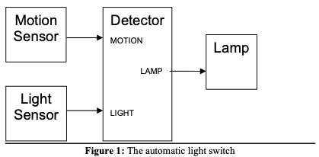

Psudo-code describing the function of the automatic light switch

while (true) {  
boolean motion = isMotionDetected();   
boolean light = isLightDetected();  
boolean lamp = motion && !light;  
showLight(lamp); }

Table 1: Symbol Mapping

|  |  |
| --- | --- |
| Name | Symbol |
| Motion Sensor | M |
| Light Sensor | L |
| Lamp | Lamp |

Table 1 lists the symbols used in the rest of the document

Table 2: Truth table for the automatic light switch

|  |  |  |
| --- | --- | --- |
| M | L | Lamp |
| 0 | 0 | 0 |
| 0 | 1 | 0 |
| 1 | 0 | 1 |
| 1 | 1 | 0 |

Table 2 describes all possible outcomes for this device, the table specifically shows that the lamp will only automatically turn on when there is motion and no light detected.

Boolean Expression of the truth table

M * ! L = Lamp

**Implementation**

Figure 2: Implemented automatic light switch

The automatic light switch is implemented as seen above in figure 2 with each output labeled.

**Testing**

Figure 3: Log of outputs from the designed device

The log is similar to the truth table seen above in table 2. This demonstrates that the implemented design functions appropriately.

**Conclusion**

Logisim can now be used properly, and the device works as expected. It only turns on when there is both motion detected and no light detected.